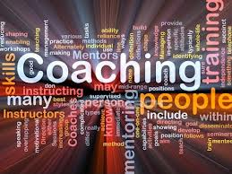
Coach/ Club Handy Resources
- minimodcoach.com
- coachrugbyleague.com.au
- completeleaguecoach.com
- totalperformance.com.au
- coachseye.com
- ausport.gov.au
- playbytherules.net.au
- goodsports.com.au
- keyhealthindicators.com.au
- sportplan.com
- rlcm.com.au

No1 May 2013

