Guide to using MySideline Manager - Matches (Live Scoring)

MySideline Manager is Internet based access and not an app like the old MyLeague Manager.
Note: It is recommended to access MySideline Manager via Google Chrome or Mozilla Firefox both of which are available via the APP store
Mozilla Firefox
Google Chrome
While you may be able to access it via Internet Explorer or Safari, there may be functionality issues.
- Logon via https://manager.mysideline.com.au/login

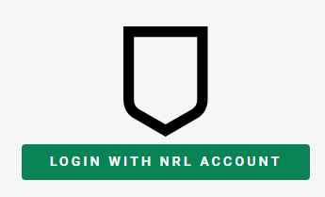
As instructed MySideline Manager uses your NRL account ID (e-mail address) to authenticate.

Click on LOGIN WITH NRL ACCOUNT. If you have multiple accounts registered under your ID, it will ask you to select one.

- Once you have successfully logged in you should get the MySideline Dashboard
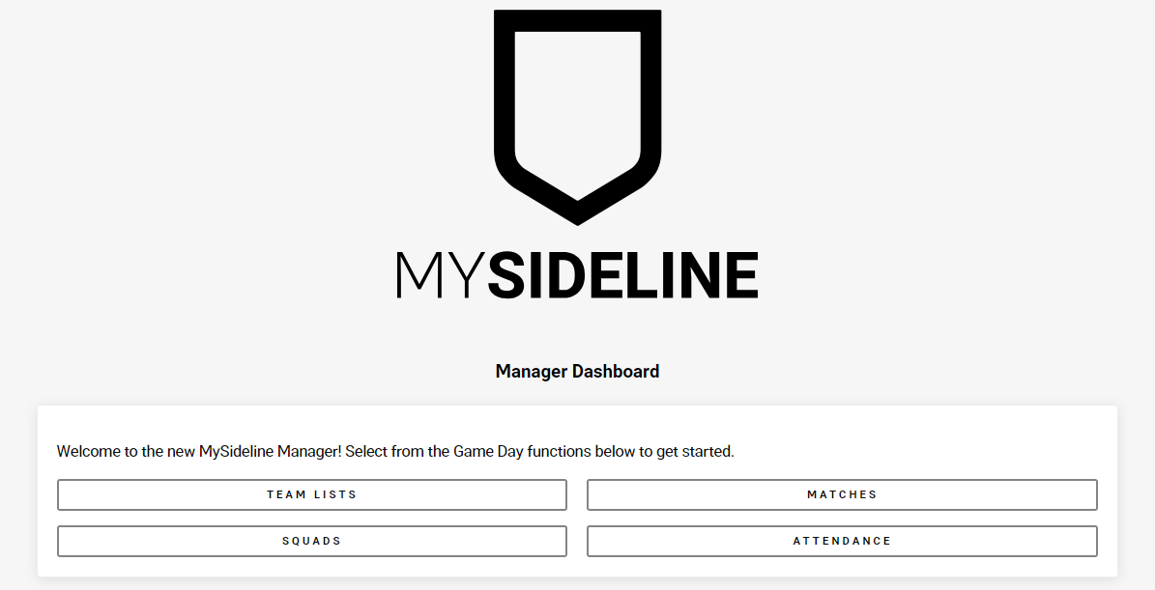

SELECT and STARTING A MATCH

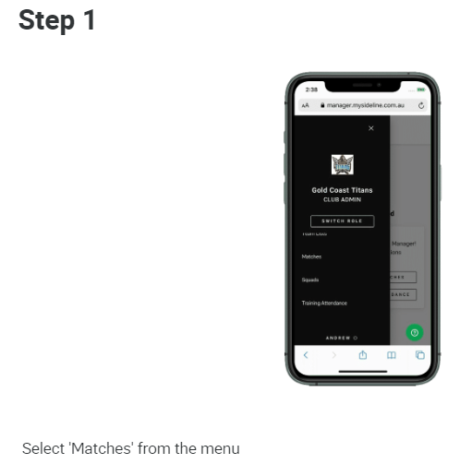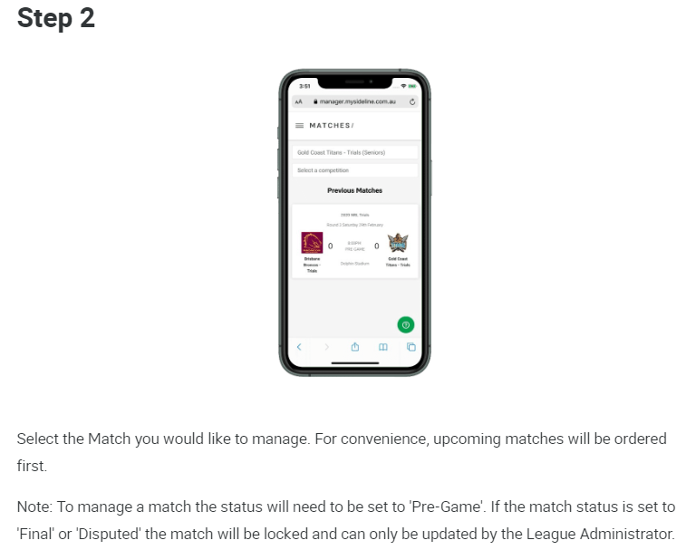
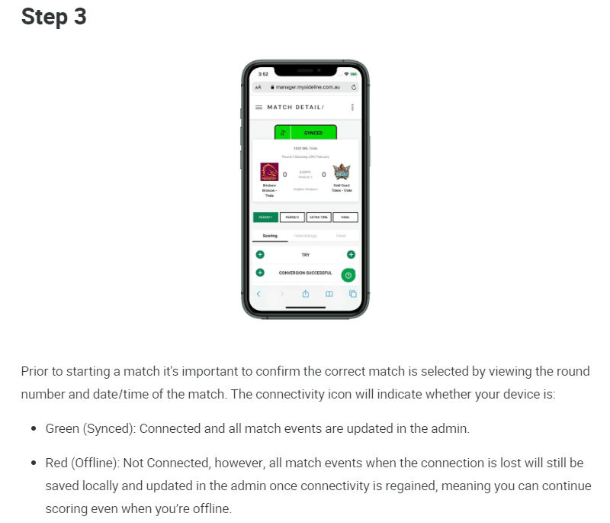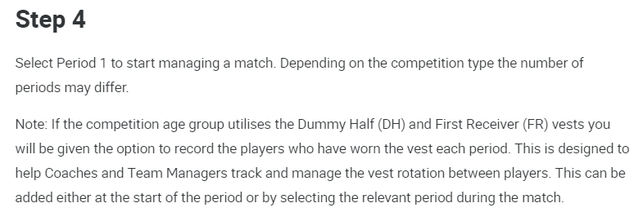
SCORING a MATCH
- Click on the PERIOD 1 button to commence the match.
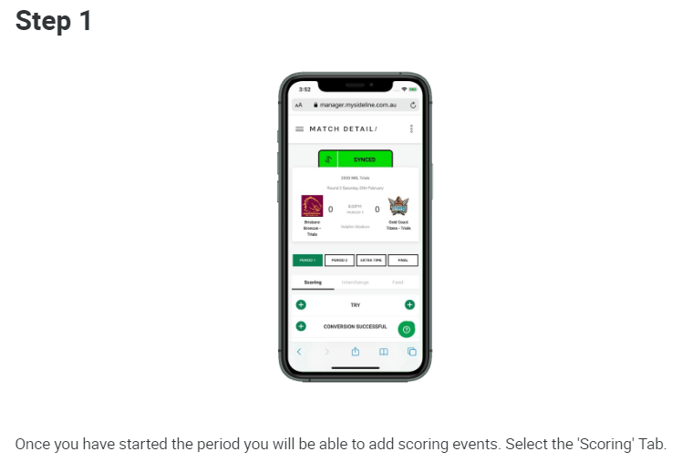
- When points have been scored by your team, click on plus button (+) for TRY or CONVERSION SUCCESSFUL etc. If you have correctly submitted your team list, you will have the option to choose the scoring player and the time it was scored (from the time keepers’ clock). While its not the preference, if a player isn’t visible just select Unknown Scorer
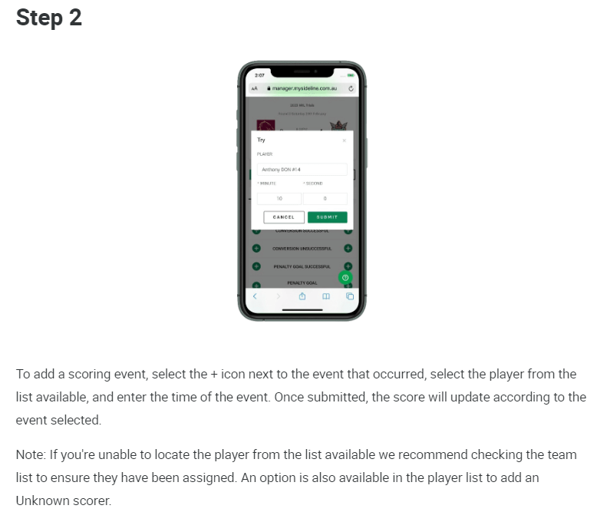

- If an error is made, click on the FEED tab for editing
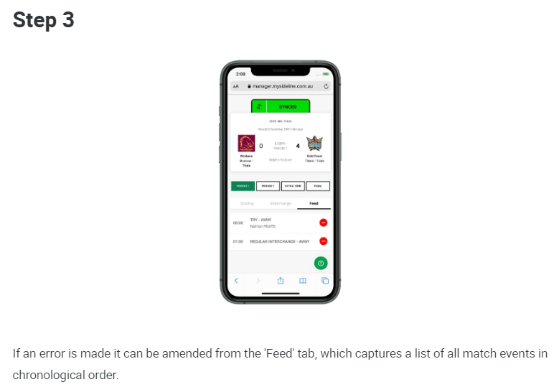
- Click on the PERIOD 2 once the 2nd half commences and follow the same process as in PERIOD 1. Note: While we are currently having 2 additional drink breaks due to COVID-19, resumption from the 1st drink break is still considered PERIOD 1. The 2nd half being PERIOD 2 commences on resumption of play following the siren at the end of the 1st drink break.

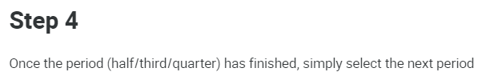

- When the final siren is sounded, if you click on FINAL, it will allow you to enter the game’s final score, remembering your score is the side showing as per match e.g. Left side is generally the home game side

Questions and Troubleshooting

Q. How can I get more information about MySideline Manager
A. It is recommended that all Team Managers and Coaches complete the MySideline Managers course at https://www.playrugbyleague.com/manager

Q. The SYNCED tab is showing up as RED instead of GREEN
A. This means possible mobile reception issues. Continue as normal as the data is stored locally and will automatically update when service is restored

Q. When points are scored, no player name is visible to select
A. This is most likely because the player has not been added to the team list. Just select UNKNOWN SCORER

Q. I am unable to access the MySideline Manager Dashboard after going to https://manager.mysideline.com.au/login
A. If you received a message about needing to obtain access or access pending please contact Nicola (0403752717) or Steve (0418473127)

Q. I am unable to see all my players in my team
A. It may be that these players have not been added to your team in MySideline so please contact Nicola (0403752717) or Steve (0418473127)

Q. I am unable to follow one of the Team Admin instructions outlined above
A. Check if you are using Google Chrome or Mozilla Firefox to perform the function and if so, please contact Nicola (0403752717) or Steve (0418473127)

