Guide to using MySideline Manager - Setting up Team Lists

MySideline Manager is Internet based access and not an app like the old MyLeague Manager.
Note: It is recommended to access MySideline Manager via Google Chrome or Mozilla Firefox both of which are available via the APP store
Mozilla Firefox
Google Chrome
While you may be able to access it via Internet Explorer or Safari, there may be functionality issues.
- Logon via https://manager.mysideline.com.au/login

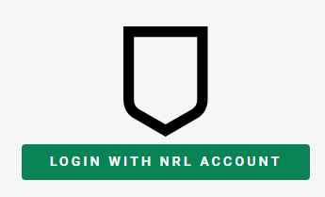
As instructed MySideline Manager uses your NRL account ID (e-mail address) to authenticate.

Click on LOGIN WITH NRL ACCOUNT. If you have multiple accounts registered under your ID, it will ask you to select one.

- Once you have successfully logged in you should get the MySideline Dashboard
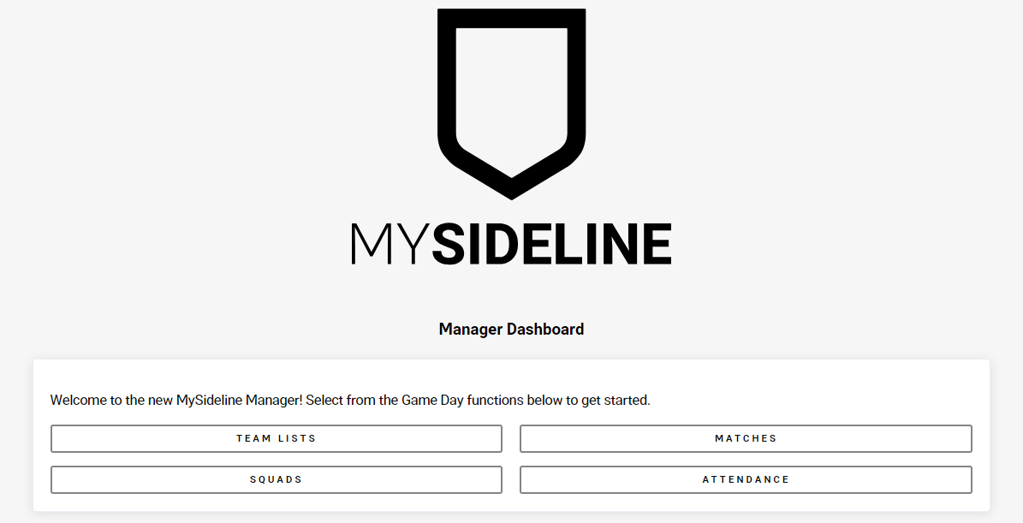

- If you select TEAM LISTS, it will take you to upcoming matches. Click on your Colts team for the selected round 1 - 10
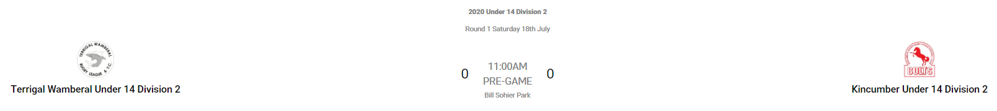

This will now allow you to players into positions, select captain and view CARDS. You can also add officials to your Team List.
Note: It will not allow you to add multiple people into the same position number.
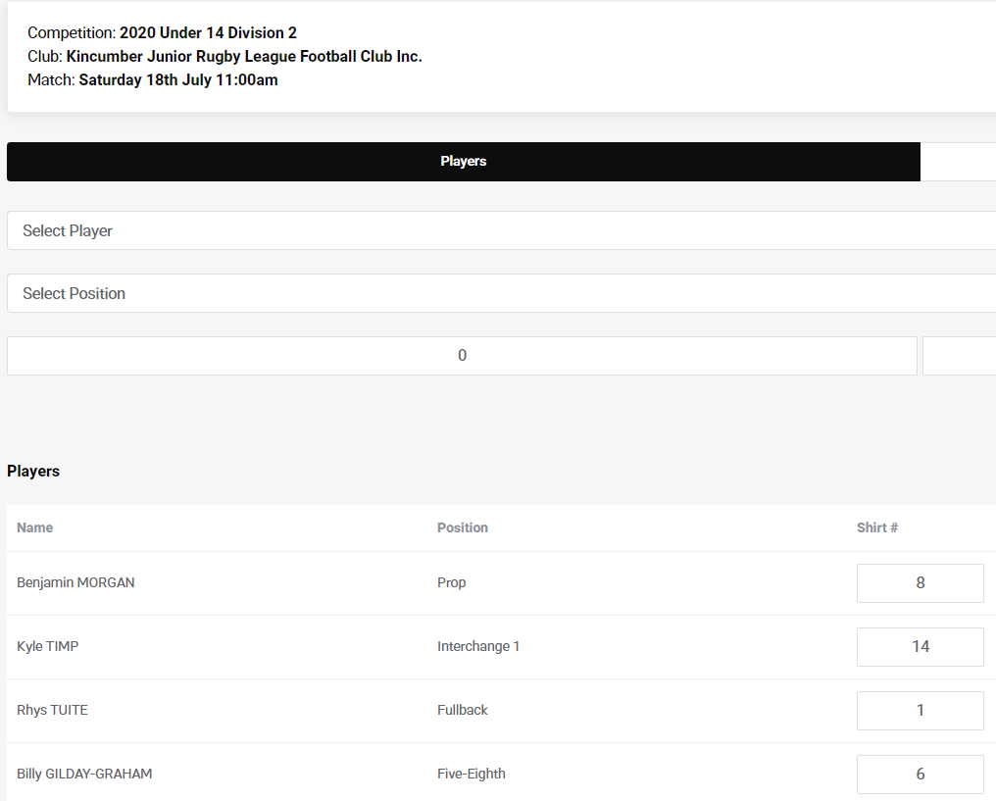
Important Note: To finalise your Team List for the round you need to ensure that you click on the SUBMIT button at the bottom right hand side for the team to be submitted for the round and for the player cards to be visible for that round. If you do not click on the SUBMIT button it won’t save any changes you have made, and you will not be able to see player cards or do live scoring (Live Scoring will commence round 2 on 25th July 2020)

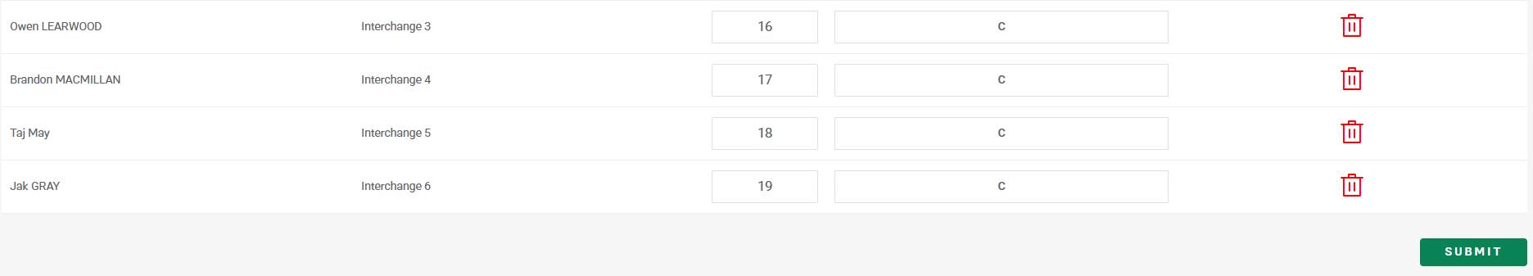
On game day, Team Managers will go into Team Lists to display and validate players and officials with their opposition Team Manager.

- Once you have created your Team List, clicking on CARDSs will allow you to view and scroll through your player and officials’ cards
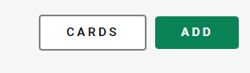
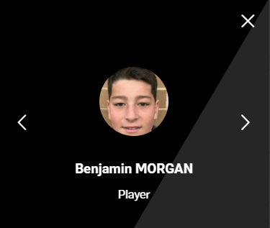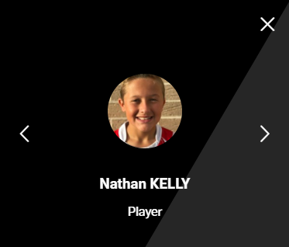

To go back to the Dashboard Menu simply click on the 3 lines next to TEAM LIST and then click on Dashboard.

Questions and Troubleshooting

Q. How can I get more information about MySideline Manager
A. It is recommended that all Team Managers and Coaches complete the MySideline Managers course at https://www.playrugbyleague.com/manager

Q. I am unable to access the MySideline Manager Dashboard after going to https://manager.mysideline.com.au/login
A. If you received a message about needing to obtain access or access pending please contact Nicola (0403752717) or Steve (0418473127)

Q. I am unable to see all my players in my team
A. It may be that these players have not been added to your team in MySideline so please contact Nicola (0403752717) or Steve (0418473127)

Q. I am unable to follow one of the Team Admin instructions outlined above
A. Check if you are using Google Chrome or Mozilla Firefox to perform the function and if so, please contact Nicola (0403752717) or Steve (0418473127)

Q. There is no photo for one of my players or officials
A. Photos come from players and officials’ registrations. If one is not being displayed, please contact Nicola (0403752717) or Steve (0418473127)

Q. I am unable to add a player to a position, receiving a MySideline error message
A. Ensure you have not already added a person to the same position

