Using MySideline Manager

MySideline Manager is Internet based access and not an app like the old MyLeague Manager.
Note: It is recommended to access MySideline Manager via Google Chrome or Mozilla Firefox
Mozilla Firefox
Google Chrome
While you may be able to access it via Internet Explorer or Safari, there may be functionality issues.
- Logon via https://manager.mysideline.com.au/login

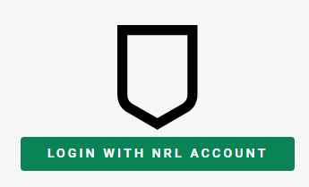
As instructed MySideline Manager uses your NRL account ID (e-mail address) to authenticate.

Click on LOGIN WITH NRL ACCOUNT. If you have multiple accounts registered under your ID, it will ask you to select one.

- Once you have successfully logged in you should get the MySideline Dashboard
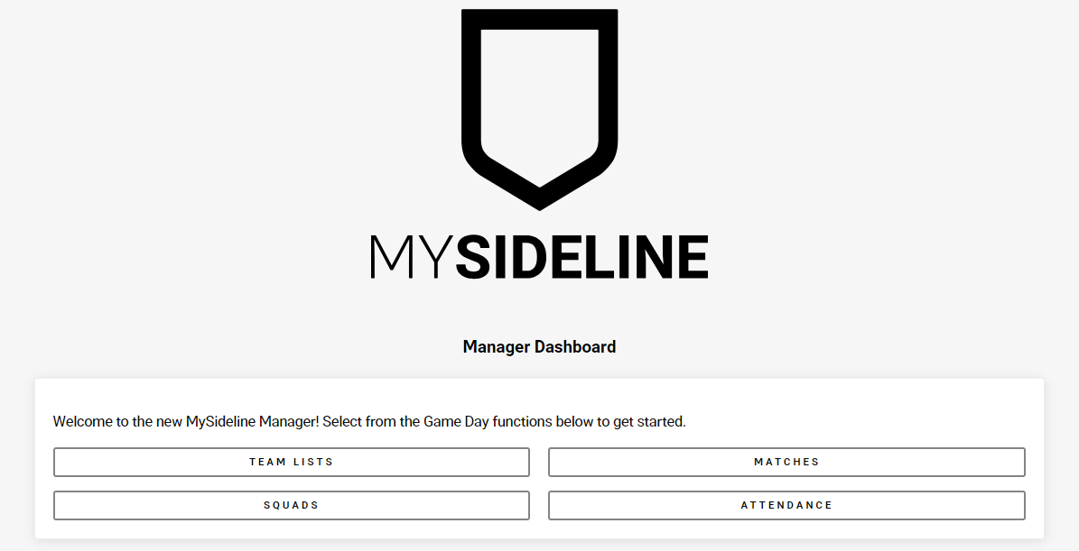

- If you select TEAM LISTS, it will take you to upcoming matches. Click on your Colts team for the selected round 1 - 10
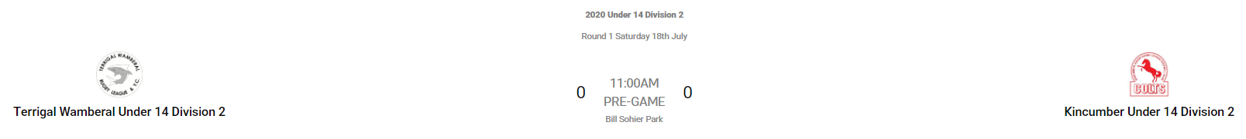

This will now allow you to players into positions, select captain and view CARDS. You can also add officials to your Team List.
Note: It will not allow you to add multiple people into the same position number.
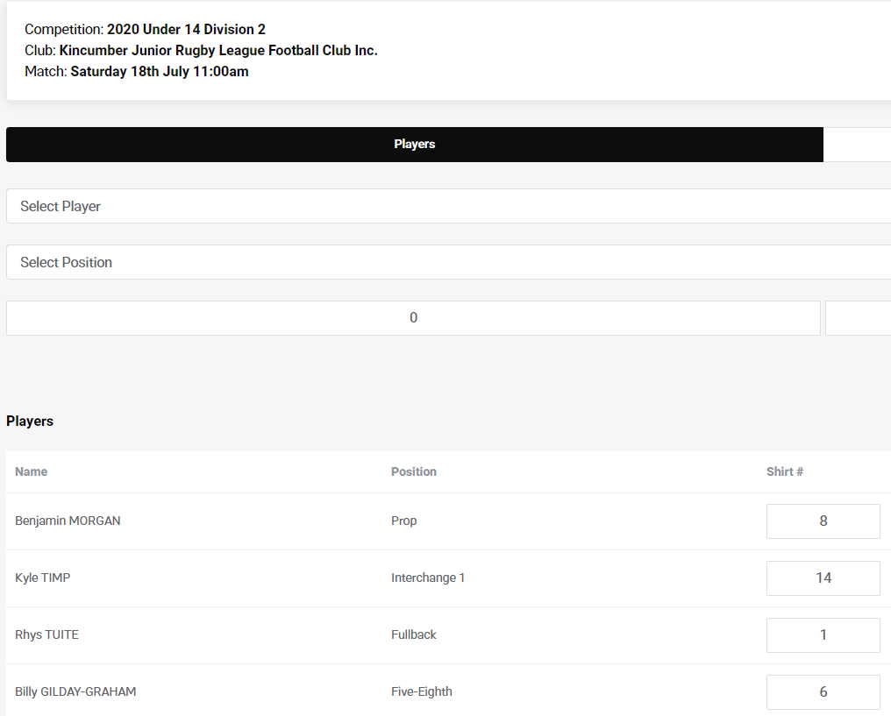
- Once you have created your Team List, clicking on CARDSs will allow you to view and scroll through your player and officials’ cards
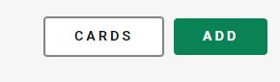
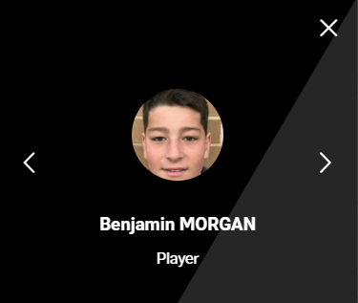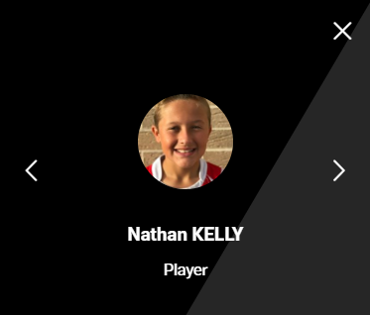

To go back to the Dashboard Menu simply click on the 3 lines next to TEAM LIST and then click on Dashboard.
- To create your SQUAD, start by clicking on SQUAD from your Dashboard
In most instances your SQUAD should already be added. You can confirm this by clicking on Current Squad.
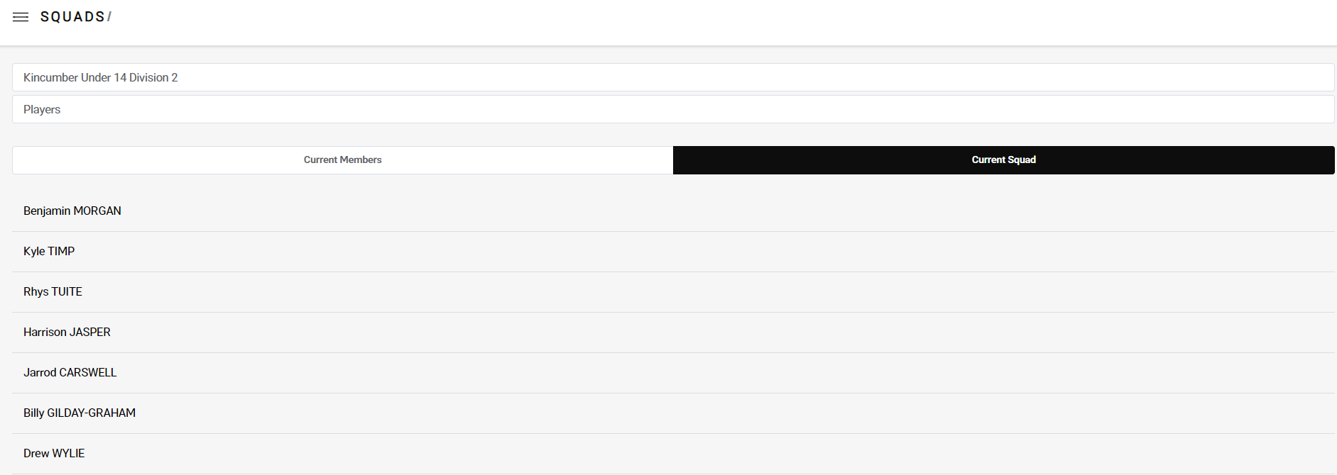

If there are new players not in your SQUAD, they should appear under Current Members. You can move these across simply by simply clicking on the name and then ADD TO SQUAD
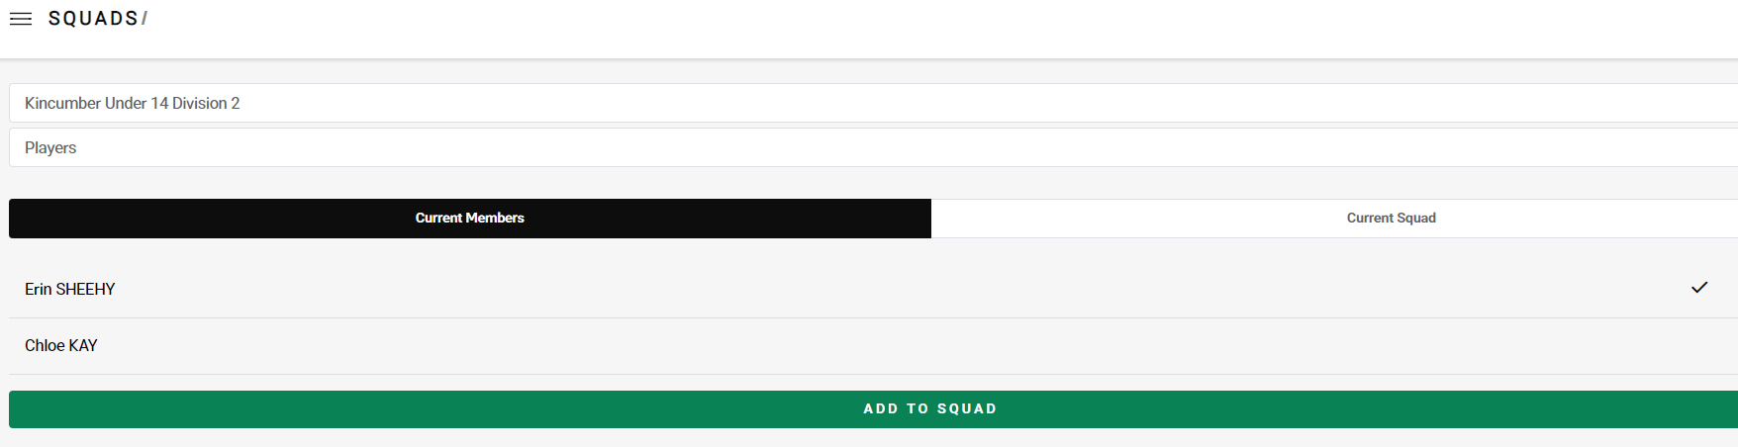
- The MATCHES function is for recording Scoring but will not be used at the start of the system. Managers and Coaches will be advised if this changes throughout the season and further instructions will be provided.

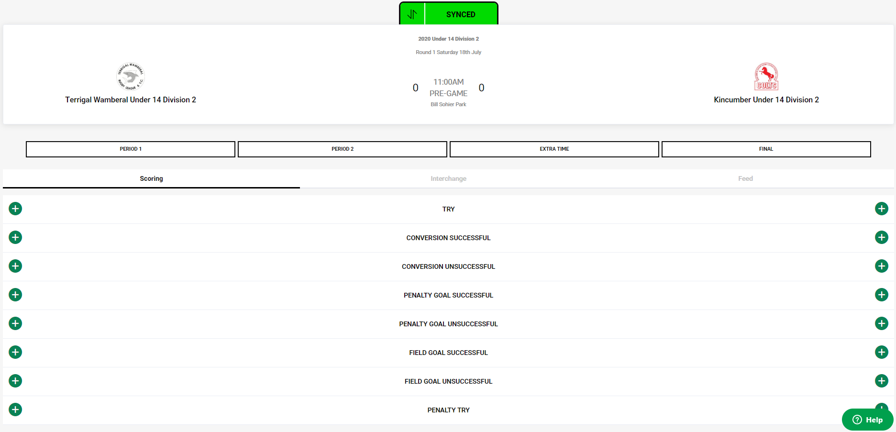

- Training Attendances is a feature of MySideline used to record attendance of players and officials at all training sessions and games. We currently haven’t been instructed about using this feature, but it can be set up.
To set it up you basically select a date and time for the Training Session.

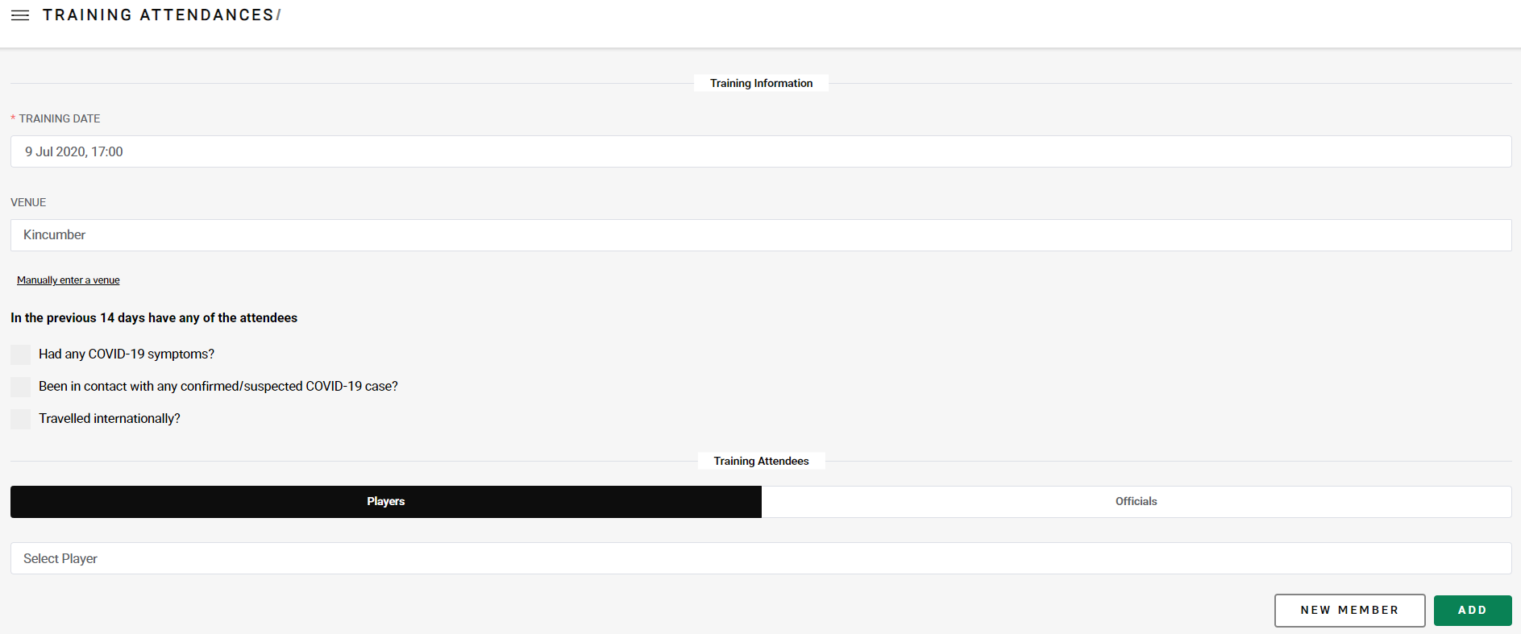

You firstly would need to setup your player and officials list. To do this click in the Select Player field which should bring up a list of all your players in your team. Highlight one and click on the ADD button

Once you have added all your Players and Officials you then have the option to select one of the 3 if applicable. If not applicable, then leave it blank.
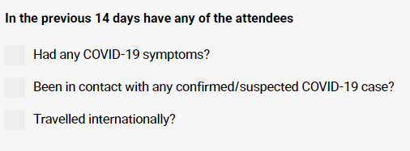

Once you click on the SUBMIT button on the bottom of the page it should save this team list.

Known Errors and Troubleshooting

Q. I am unable to access the MySideline Manager Dashboard after going to https://manager.mysideline.com.au/login
A. If you received a message about needing to obtain access or access pending please contact Nicola (0403752717) or Steve (0418473127)

Q. I am unable to see all my players in my team
A. It may be that these players have not been added to your team in MySideline so please contact Nicola (0403752717) or Steve (0418473127)

Q. I am unable to follow one of the Team Admin instructions outlined above
A. Check if you are using Google Chrome or Mozilla Firefox to perform the function and if so please Nicola (0403752717) or Steve (0418473127)

